Contents

1. Overview 2
Document Overview 2
App Functionality Overview 2
Solution Architecture 2
Admin Access 3
ReadOnly Access 3
2. Environment Details 4
Environment Variables 4
Connection References 4
3. Data Sources 5
4. Solution Components 5
Power Apps Application 5
Power Automate Flows 5
5. User Permissions 6
Users with Admin Permission 6
Users with READONLY Permission 6
6. Screen Design 7
Splash Screen 7
Dashboard (Filter Hidden) 8
Dashboard (Filter Visible) 8
View Item 9
Edit Item 9
Delete Item 10
Add New Item 10

1. Overview

Document Overview
This document outlines the solution breakdown of the *NAME REDACTED* Power Apps App, detailing all solution components.

App Functionality Overview
The *NAME REDACTED* applications are used to store all the data on contracts let with certain providers for resources

Solution Architecture

The solution utilizes SharePoint as its primary data source, with 10 SharePoint lists, 7 of which are accessed and modified directly through the Canvas Application called “WM Reply Example Project”.

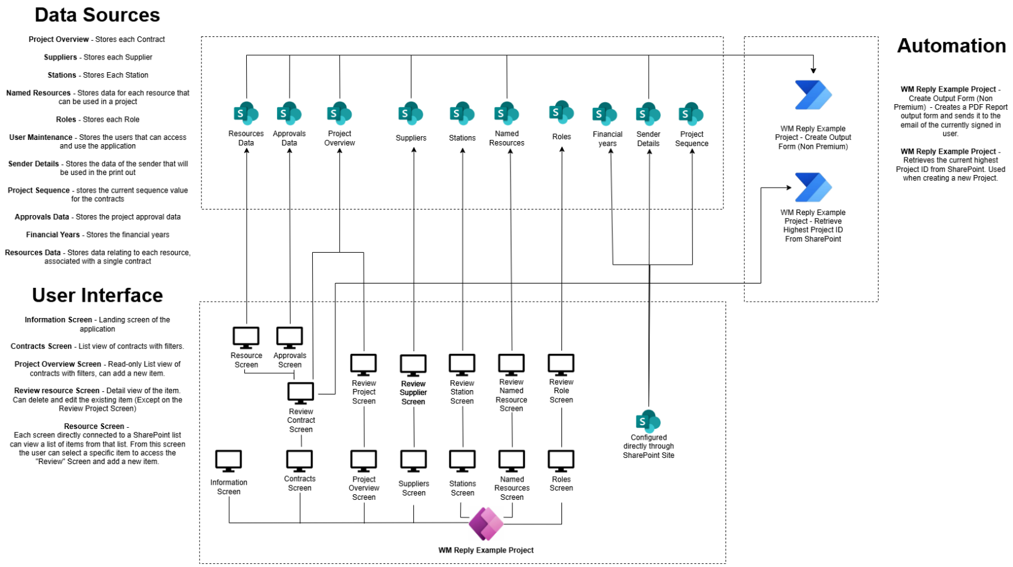

Access
Users are either individually added to SharePoint site Owners Group or the following groups:

SharePoint Site Name

Development SharePoint Groups | *SharePoint Site LinkRedacted*
Test SharePoint Groups | *SharePoint Site LinkRedacted*
Production SharePoint Groups | *SharePoint Site LinkRedacted*

The app is shared with the following groups:

For Non-Production environment of Power app:

*App Name Redacted* Database

User needs to be added as member in following Entra Groups.
- *App Name Redacted*-Owners
- *App Name Redacted*-Users
For Production environment of Power app:

User needs to be added as member in following Entra Groups.

- *App Name Redacted*-Owners
*App Name Redacted*-Users

The solution and its components are owned by the service account:

*Service Account Name Redacted*

2. Environment Details

*App Name Redacted* Database

Development Environment | Test/UAT Environment | Production Environment
*Name Redacted* - DEV | *Name Redacted* – UAT | *Name Redacted*
Environment - Dev | Environment - Test | Environment - Live
Solution - Dev | Solution - Test | Solution - Prod
App - Dev | App - Test | App - Prod

Environment Variables
Details and values for Environment Variables are stored in this worksheet: WM Reply Example Project – Environment Variables.xlsx (Insert Link to Document)

Connection References
Connection references use the Service Accounts’ connections in all environments.

*Name Redacted*

Connection Reference | Connection | Use
*Name Redacted*-ExcelOnline | Excel Online | Used in Import Data Flows: “Import Excel Data into a SharePoint List (SharePoint List)”
*Name Redacted* -Outlook | Outlook | Used in Flow: “*Name Redacted* Database – Create Output Form”
*Name Redacted* -SharePoint | SharePoint | Used in Import Data Flows: “Import Excel Data into a SharePoint List (SharePoint List)”  Used in “*Name Redacted* – Create Output Form”
*Name Redacted* -WordOnline | Word Online | Used in Flow: “P *Name Redacted* – Create Output Form”

3. Data Sources

All data is stored within SharePoint. Each environment has a separate SharePoint site with an identical set of lists and libraries. Links to the sites are detailed below:

*Name Redacted*

Development SharePoint Site | Test/UAT SharePoint Site | Production SharePoint Site
*Name Redacted* DEV | *Name Redacted* UAT | *Name Redacted*

Application data source breakdown: WM Reply Example Project – Data Structure.xlsx (Insert Link to Document)

4. Solution Components

Both of the applications contain effectively identical flows, with the only difference being the SharePoint sites and lists targeted by the flows

Power Apps Application

*Name Redacted*

Power Automate flows
*NAME REDACTED* – Create Output Form (Non Premium)
- Trigger: Activated from a Power App
- Summary: This flow exports the selected contract and its associated data into a .PDF document format and sends the exported file to logged-in users email address.

The following detailed flows are not packaged as part of the solution, but are stored in the Developer
Environment

*NAME REDACTED* – Import Excel Data into SharePoint List (Approvals Data)
- Trigger: Manually Activated from Power Automate
- Summary: This flow imports data from a select .xlsx document into the production version of the application

*NAME REDACTED* – Import Excel Data into SharePoint List (Named Resources)
- Trigger: Manually Activated from Power Automate
- Summary: This flow imports data from a select .xlsx document into the production version of the application

*NAME REDACTED* – Import Excel Data into SharePoint List (Project Overview)
- Trigger: Manually Activated from Power Automate
- Summary: This flow imports data from a select .xlsx document into the production version of the application

*NAME REDACTED* – Import Excel Data into SharePoint List (Resources Data)
- Trigger: Manually Activated from Power Automate
- Summary: This flow imports data from a select .xlsx document into the production version of the application

*NAME REDACTED* – Import Excel Data into SharePoint List (Roles)
- Trigger: Manually Activated from Power Automate
- Summary: This flow imports data from a select .xlsx document into the production version of the application

*NAME REDACTED* – Import Excel Data into SharePoint List (Stations)
- Trigger: Manually Activated from Power Automate
- Summary: This flow imports data from a select .xlsx document into the production version of the application

*NAME REDACTED* – Import Excel Data into SharePoint List (Suppliers)
- Trigger: Manually Activated from Power Automate
- Summary: This flow imports data from a select .xlsx document into the production version of the application

*NAME REDACTED* – Import Excel Data into SharePoint List (Suppliers)
- Trigger: Manually Activated from Power Automate
- Summary: This flow imports data from a select .xlsx document into the production version of the application

*NAME REDACTED* - Delete all data in Resources, Approvals, Project Overview and Named Resources
- Trigger: Manually Activated from Power Automate
- Summary: This flow deletes all of the following information. Note: This flow was set up to delete the data in the production version of the environment. After deployment, all references to the production site will be delete to prevent accidental running.

5. User Permissions

WM Reply Example Project – Permissions Matrix

